***THE LIGHTNINGS***

**www.the-lightnings.de**

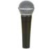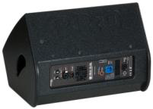

Shure SM 58

**Bassdrum**

**Snare Bassdrum**

**Snare**

**Hihat**

**Standtom**

**3 Toms**

**2 Overhead**

**1 Aux Monitoring**



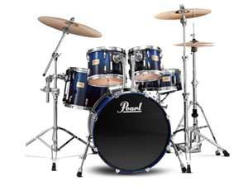

DI Out

**SM 57**



**SM 57**

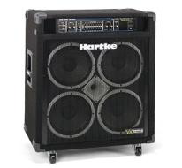



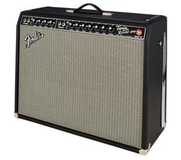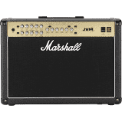 **DI Out**  **Shure SM 57**

 **Shure SM 57**

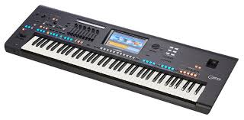  DI Out



Shure

SM 58



Shure

SM58

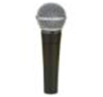

**DI**



Shure SM 58